**How to register in Jira**

1. Go to [**https://www.atlassian.com/software/jira**](https://www.atlassian.com/software/jira)



1. No need to select second product. Click **next.**

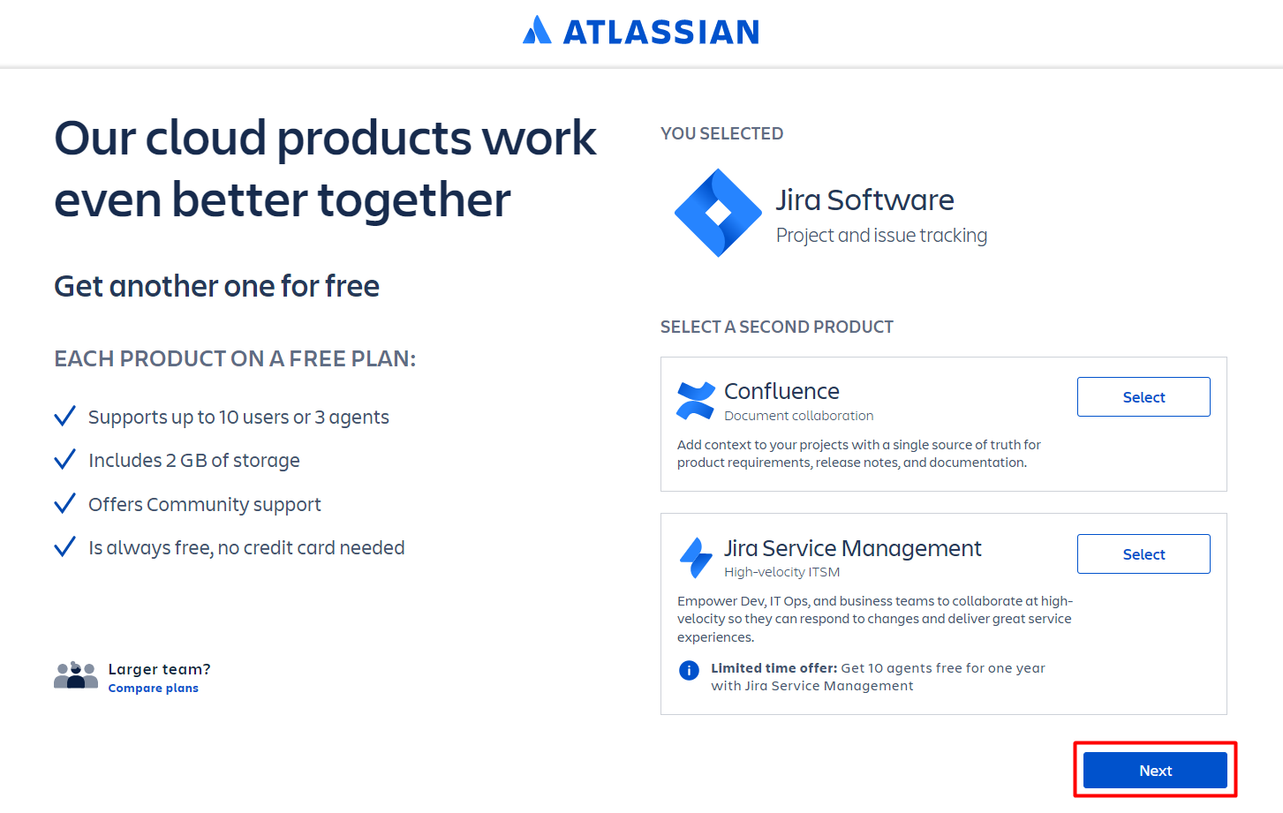

1. Continue with google or other email

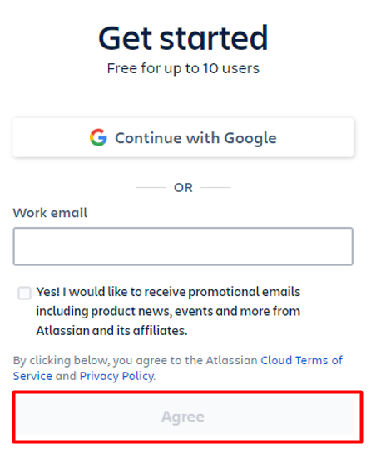

1. Depending on the way you chose to register, there will be some additional verification that you need to perform. Verify your e-mail or allow google to use your account with Atlassian.
2. 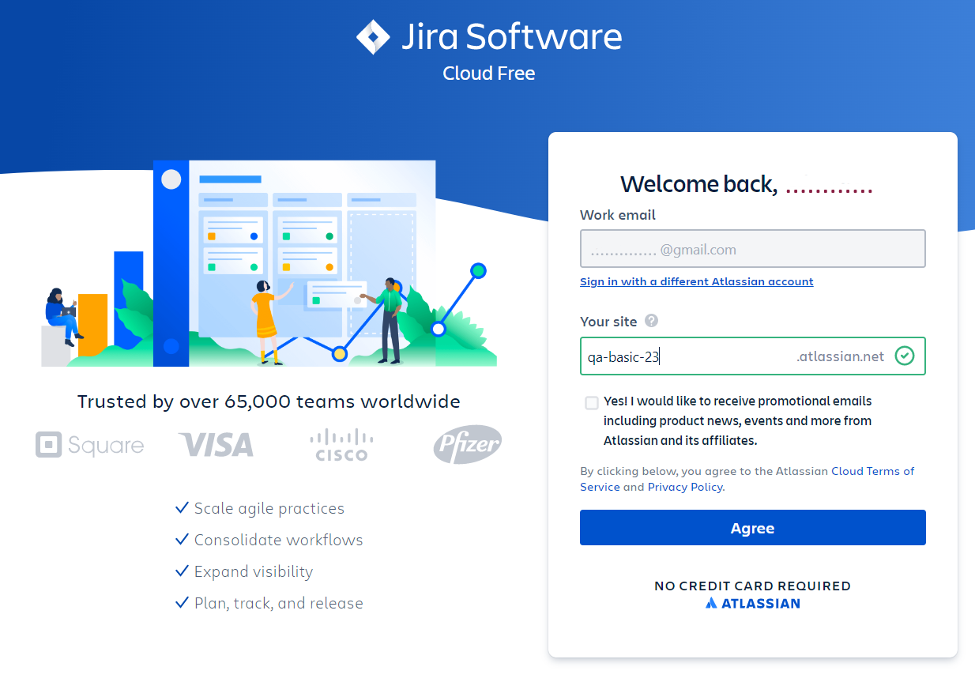Now you have to create your site with Jira. Choose a meaningful name and follow the naming rules:  
   "Your site name must be 3 or more lowercase letters and/or numbers. Hyphens are ok if they’re in the middle."
3. You can skip the following questions



1. Check "Testing and quality assurance (QA) or you can skip this question as well.

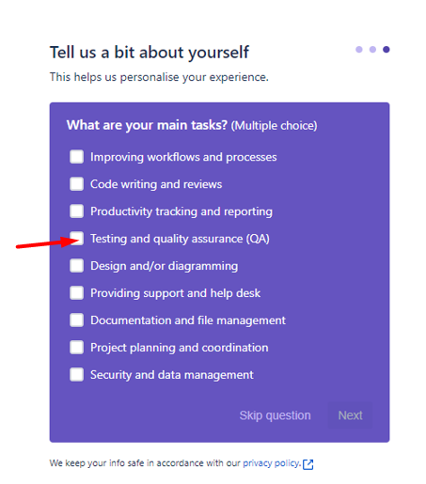

1. Give it some time to create your site.



1. Once done, you will be prompt to answer new series of questions. You can skip those or you can answer as follows:
   1. Skip

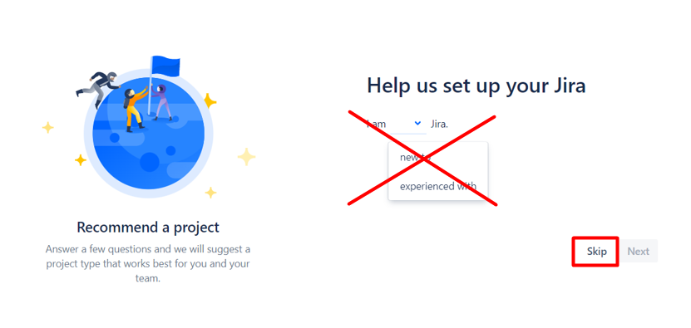

* 1. Answer

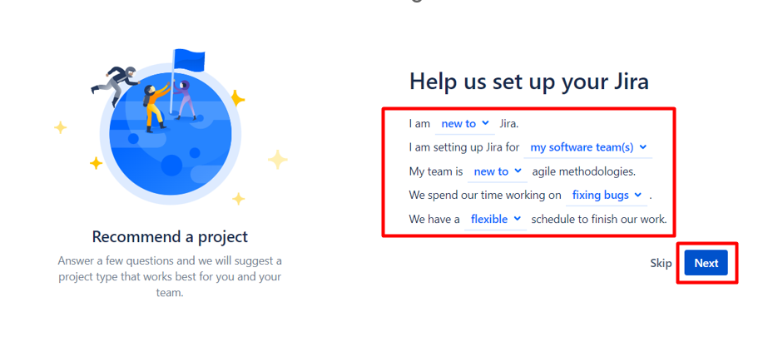

1. Next you will have to create your project. Click on "More templates".

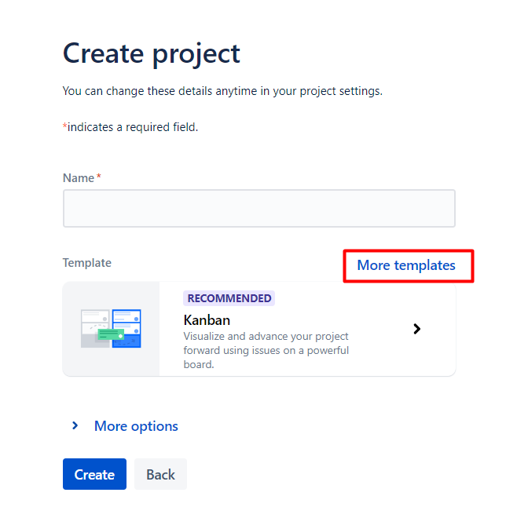

1. And choose "Bug Tracking"

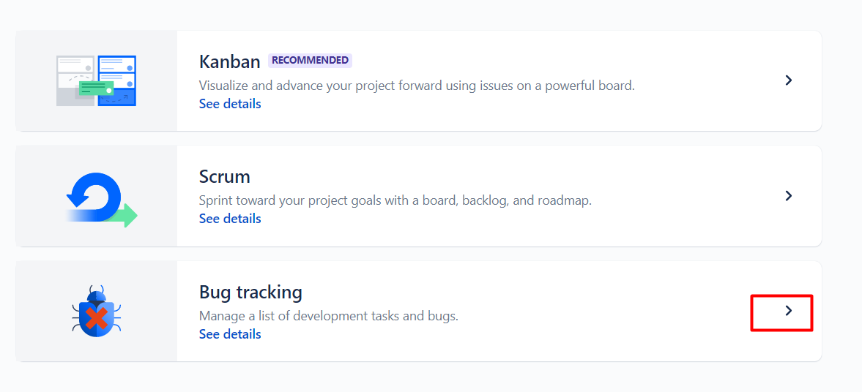

1. Now, choose a meaningful name for your project and click "Create".

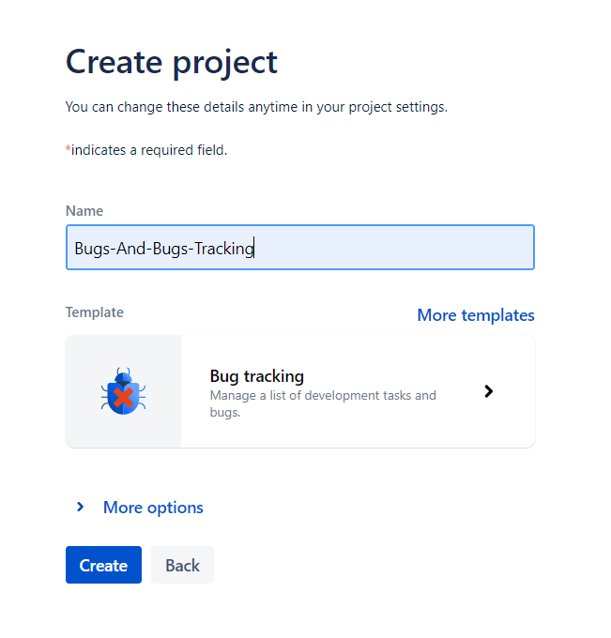

1. Skip the following tools.



1. Your project is ready.

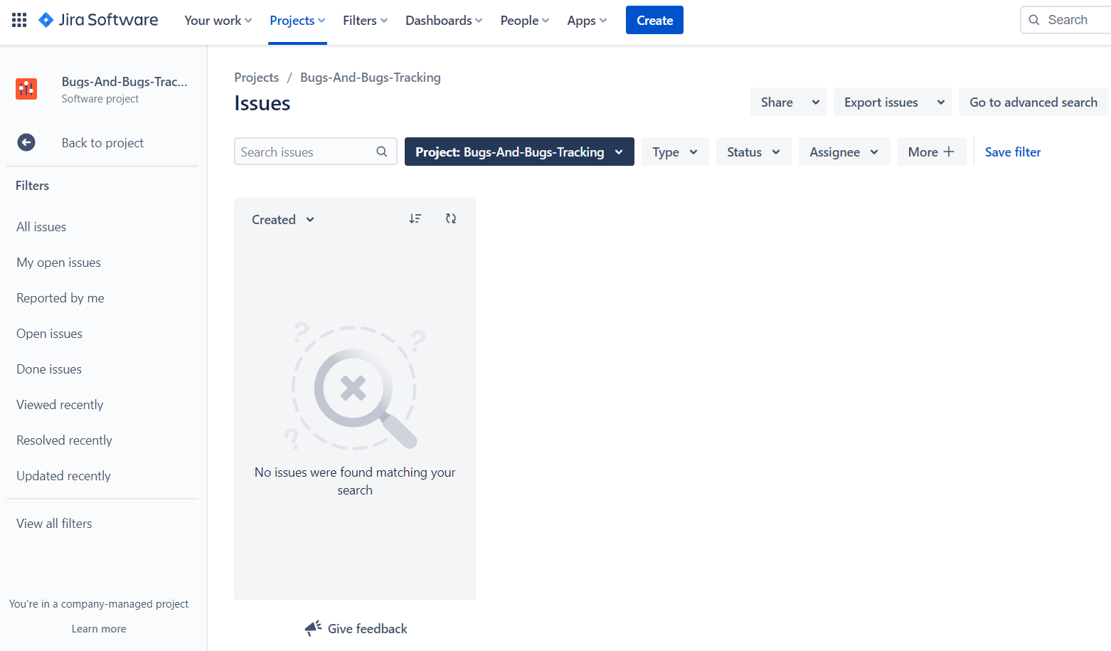

1. The next time you visit <https://www.atlassian.com/> and log in, click on the button and choose "Jira Software" to navigate to your project/s



